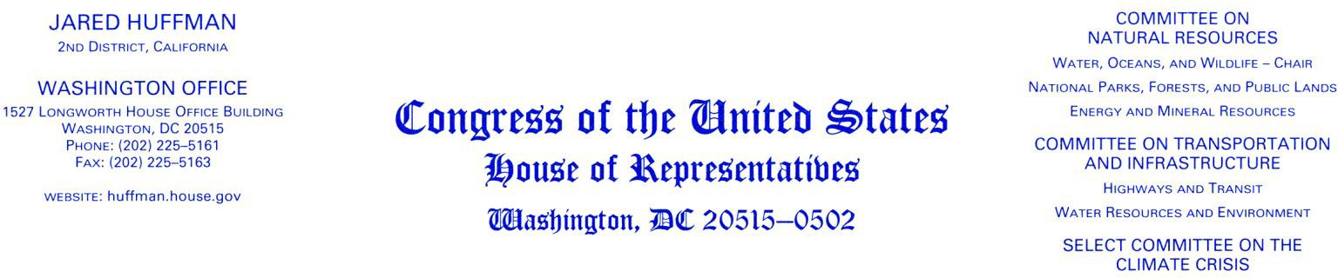
July 16, 2020

Dr. Neil Jacobs
Assistant Secretary of Commerce for Environmental Observation and Prediction Acting Under Secretary of Commerce for Oceans and Atmosphere
National Oceanic and Atmospheric Administration 1401 Constitution Ave. NW
Washington, DC 20230 Dear Dr. Jacobs:
As you’re well aware, the pandemic has had severe impacts on U.S. fisheries and fishing communities. The fishing industry is a large part of our economy and seafood is an essential part
of our food system, but due to the pandemic and associated necessary closures, fishermen across the country are bearing the brunt of severe economic losses due to decreased demand.
Unfortunately, it is unlikely that the economic and health risks are going to decrease in the near future, and it is possible that it will take much longer to return to conditions prior to the onset of the pandemic.

I am concerned that your agency’s response to the pandemic has been unclear and inconsistent, and at times lacked the appropriate thoughtfulness and proactive planning in order to fully support fishing businesses’ recovery and sustainable fisheries moving forward. I appreciate the work of your Agency to listen to stakeholders and address their needs, and I also understand your Agency is adapting to the challenges presented by the COVID-19 pandemic. However, these unprecedented conditions will persist into next year and possibly later, and it is your responsibility to respond and react to the ongoing challenges appropriately. To that end, I have several concerns.

First: It is alarming that your agency has issued internal guidance to limit references to the pandemic in its communications, as reported last month.1 In this guidance, the preferred approach states, “Make no reference to anything COVID related”; the second approach states, “Use general terms to discuss local or regional travel restrictions or refer to CDC guidance”; and the third approach states, “Limited direct mention of COVID-19 or pandemic” to be used on “an extremely limited basis”. While I understand that there may be rulemaking or other standard agency actions unrelated to COVID, there are also many actions that the agency is taking due to COVID and related impacts, and that should be made explicitly clear for the public. Confusingly,

1 https://www.npr.org/sections/coronavirus-live-updates/2020/06/26/883990032/federal-agency-tells- employees-no-reference-to-anything-covid-related; Document accessed https://www.alaskapublic.org/wp- content/uploads/2020/06/COVID-19-guidance.pdf

the preferred approach in the guidance includes an example that relates to an action that is in response to COVID impacts without any actual mention of COVID:
Since [insert appropriate timeframe - e.g., mid-June], the fishery has experienced: [insert specific facts, impacts, etc. - e.g., disruptions to market, crew members unable to access the ports, closures of harbors and boat ramps, disruptions to obtaining needed supplies to go fishing]. As a result, NMFS is [insert what we’re doing - e.g., implementing this emergency rule; modifying trip limits; increasing season length; taking appropriate action].

I’ve also seen inconsistent communications regarding the pandemic – NOAA includes reference to COVID in some announcements, yet federal rulemaking only states “Government health mandates and travel restrictions.” To try to manage resources under your jurisdiction without any mention of COVID during a time in which COVID is impacting nearly every part of our lives is simply unacceptable.
- Who developed the internal guidance and what was the basis of these options, particularly the ‘preferred approach’? Was there input from public health experts and career staff?
- Even if, as claimed, NOAA developed this guidance to ensure consistency in communications, what is the purpose of limiting references to the ongoing pandemic?
- Does the agency plan to continue using this internal guidance document?

Second: NOAA Fisheries announced the cancellation of several fisheries surveys this summer due to COVID.2,3 I greatly appreciate that the agency is taking the health of NOAA employees and contractors seriously and carefully assessing risks based on public health guidance. It is refreshing to see that level of caution and science-based decision making from this administration. It is also promising that NOAA has taken this opportunity to expand its use of new technologies like Saildrone to conduct surveys remotely. However, given the country’s current trajectory and lack of coordinated response to the pandemic, the agency should have
clear, near and long term (e.g. the remainder of this year and the next 1 -3 years) plans to address survey needs. Additionally, it is important to address how NMFS and Councils will work through the lack of data in their stock assessment work in future years.
- What was the decision-making process used to cancel these surveys? What public health information is the agency using to evaluate risks to NOAA employees?
- What additional technologies, staffing models, or new cooperative research could be used to fill this gap in the near term, and if necessary, in future years? What tools does NOAA have at its disposal now, and what would require outyear planning?
- Is there a way to involve fishermen to collect part of this missing survey data?
- How will these cancelled surveys impact fisheries management?

Third: As the agency has itself determined, the close quarters onboard fishing vessels pose a significant health risk; it may be impossible for crew to physically distance the recommended 6 feet apart to limit COVID transmission. I am aware that the agency has provided guidelines to waive human observer requirements on fishing vessels; however, we have seen a region by

2 https://www.fisheries.noaa.gov/media-release/noaa-fisheries-will-cancel-five-alaska-research-surveys-2020
3 NOAA Fisheries Cancels Three Northeast Research Surveys, bulletin sent 07/10/2020 11:30 AMEDT

region piecemeal approach that has unfairly required some to accept more risk than others. I fully support the work of observers and their critical role in sustainable fisheries management, but during a pandemic and with significant health risks that can be life threatening, I am concerned that the agency is taking a haphazard approach on this issue.
  - What is the justification for extending observer waivers in some regions but not others? Do waivers consider the recent significant increase in cases throughout the country?
  - Does the agency plan to continue using its current guidelines for observer waivers? If the guidelines are updated, will there be opportunities for stakeholder input?
  - Given that regions like the Pacific have a strong pattern of compliance and currently have an experimental electronic monitoring (EM) program, has the agency considered the use of EM when evaluating observer waivers?
  - How does the agency plan to advance the use of EM, which would be especially valuable in these types of circumstances, when human observers pose health risks and are putting themselves at risk due to the limited space onboard fishing vessels?

Fourth: I will again emphasize that our fishermen, Tribes, seafood businesses, and coastal communities are enduring significant consequences due to the pandemic. I appreciate NOAA’s work to assist impacted stakeholders; however, the federal assistance appropriated by Congress in the CARES Act has yet to reach anyone who has been impacted. It took NOAA nearly six weeks – much too long – to determine allocations. I urge you to work quickly to ensure relief
funding gets to communities as soon as possible. Most cannot afford to continue operating without this desperately needed relief, and any additional delays will make it harder for businesses to survive and threaten the economies and culture of our fishing and coastal communities.
- What is the status of the relief funding?
- How long does NOAA expect to take to review and approve state spend plans? How long does NOAA expect to take to distribute funds once plans are approved?

I would appreciate your prompt response to my questions. Thank you for your work and thank you to the entire agency’s workforce during these difficult times. Now, more than ever, it is critical that our federal agencies are adaptive, transparent, and focused on keeping their
workforce safe and addressing the real needs of the public that they serve. I hope that NOAA can continue its work in this manner and move forward with a clear plan to address this crisis and any future crises.

Sincerely,
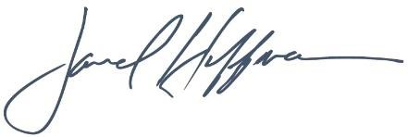
Jared Huffman Chair
Subcommittee on Water, Oceans, and Wildlife

cc: Chris Oliver, Assistant Administrator, NOAA Fisheries

